1. **Monuments of India**
2. **Taj Mahal**

The Taj Mahal is an ivory-white marble mausoleum on the right bank of the river Yamuna in Agra, Uttar Pradesh, India. It was commissioned in 1631 by the fifth Mughal emperor, Shah Jahan to house the tomb of his beloved wife, Mumtaz Mahal.

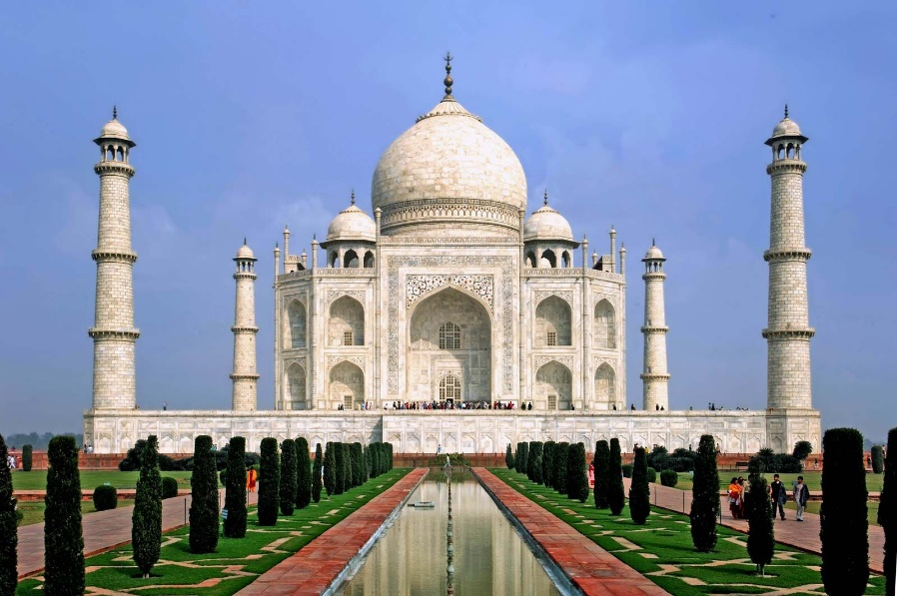

1. **Red Fort**

The **Red Fort** or Lal Qila is a historic fort in the Old Delhi, India, that historically served as the main residence of the Mughal emperors. Emperor Shah Jahan commissioned construction of the Red Fort on 12 May 1638.

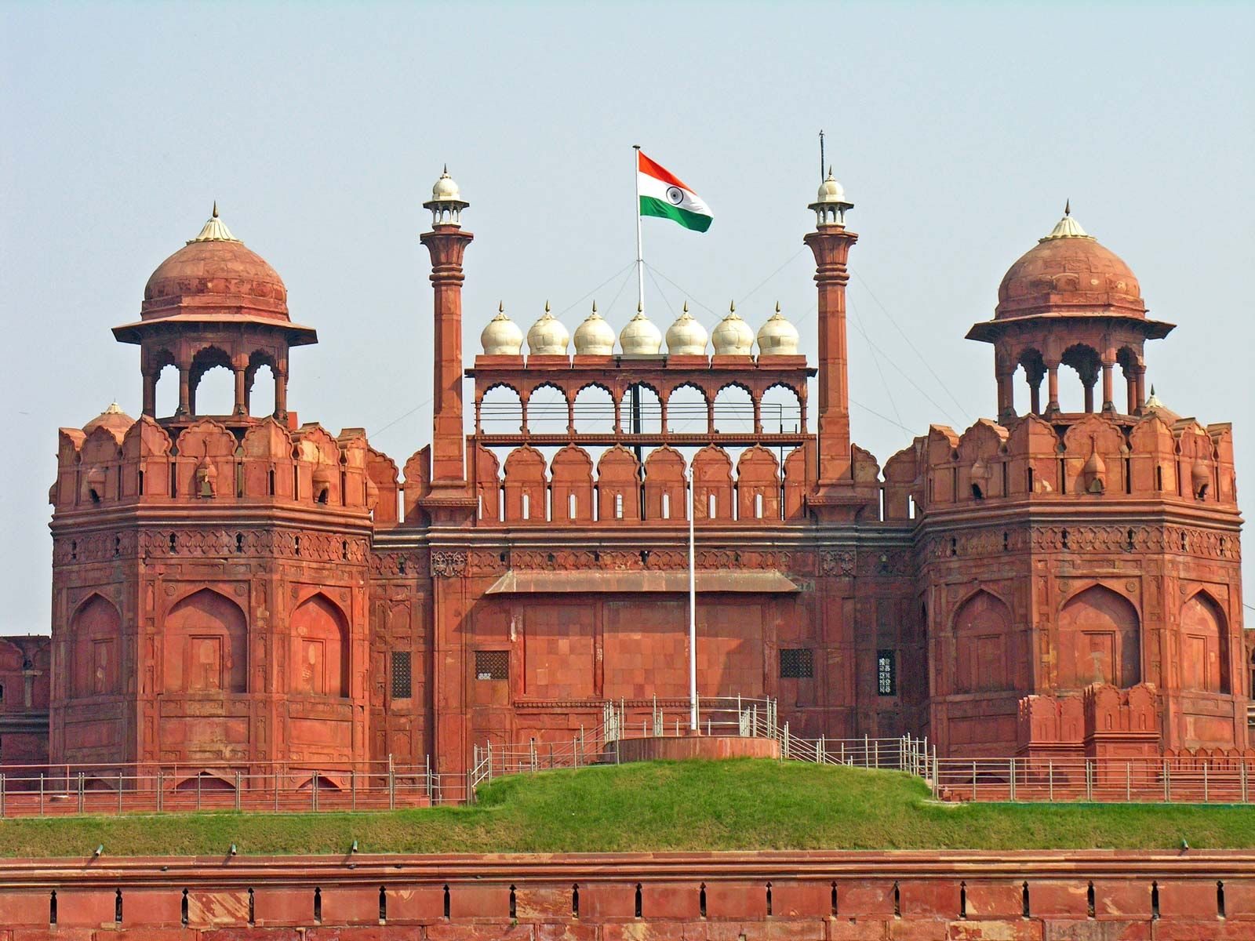

1. **Khajuraho Group of Monumnets**

**The Khajuraho Group of Monuments** are a group of Hindu and Jain temples in Chhatarpur district, Madhya Pradesh, India. Most Khajuraho temples were built between 950 and 1050 by the Chandela dynasty.

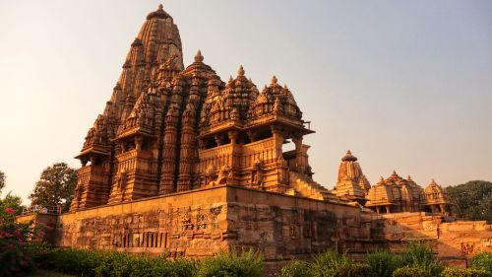

1. **Golden Temples**

**The Golden Temple** is a gurdwara located in the city of Amritsar, Punjab, India. It is famous for its full golden dome, it is one of the most sacred pilgrim spots for Sikhs.

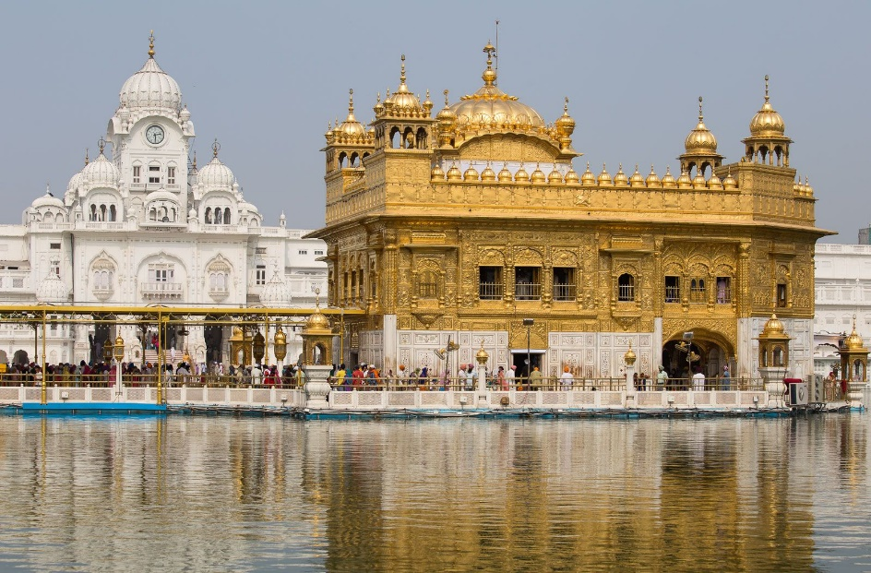

1. **Ellora Caves**

**Ellora Caves** are a multi-religious rock-cut cave complex with inscriptions dating from the period 6th century CE onwards, located in the Aurangabad District of Maharashtra, India.

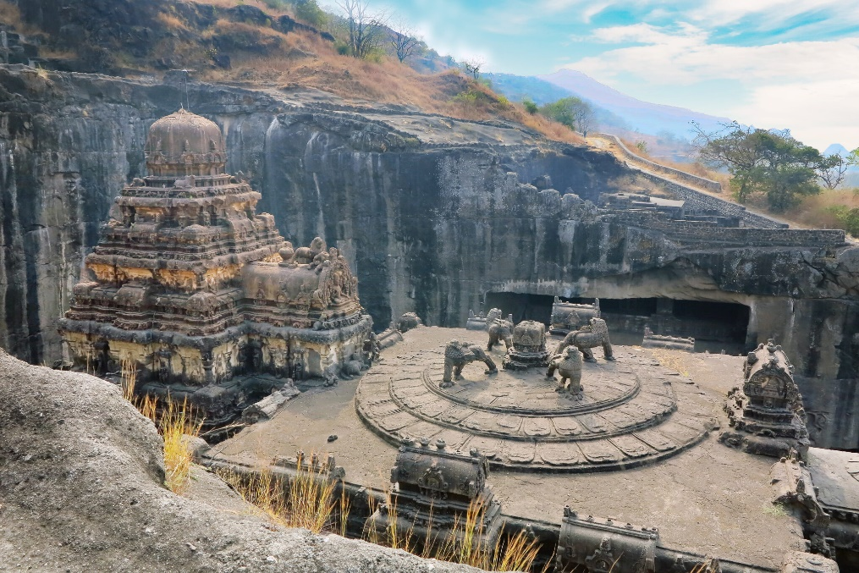

1. **Culture of India**

India’s culture is among the world’s oldest; civilization in India began about 4,500 years ago. Many sources describe it as “Sa Prathama Sanskrati Vishvavara” — the first and the supreme culture in the world, according to the All World Gayatri Pariwar (AWGP) organization.

1. **Festival**
   1. Diwali is a festival of lights, the festival represents the symbolic victory of light over darkness, knowledge over ignorance, and good over evil

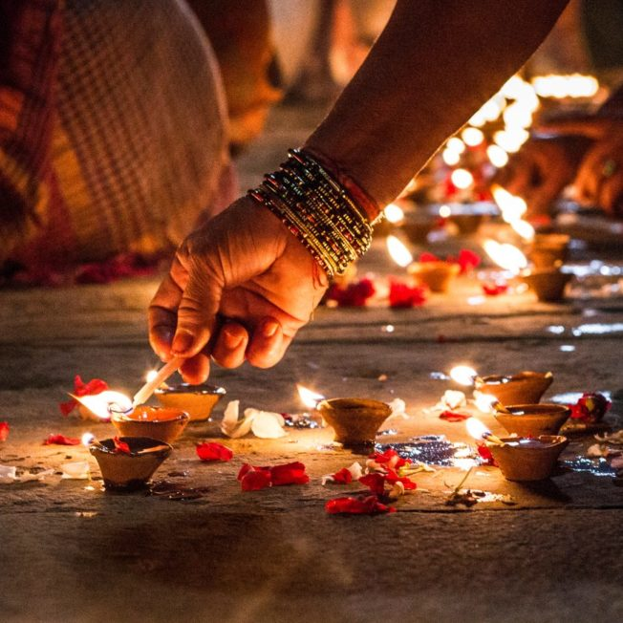

* 1. Holi, also known as the festival of colors, is a two-day celebration in India. The core value of holi is celebrating the triumph of good over evil.

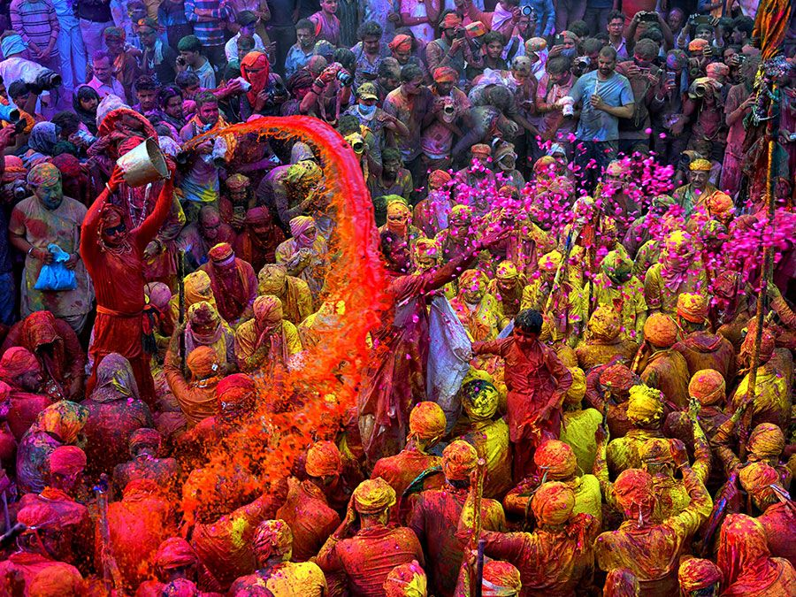

1. **Dance**
   1. Bharatanatyam is an Indian classical dance form that was originated in Tamil Nadu. It expresses South Indian religious themes and spiritual ideas, particularly of Shaivism and in general of Hinduism.

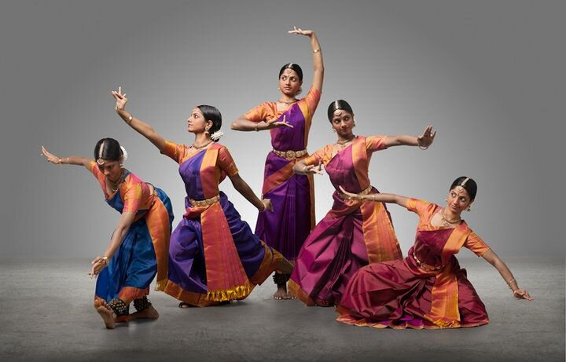

* 1. Bhangra is a type of traditional folk dance originating from the Punjab. It is done in the season of harvesting. According to Manuel, bhangra is especially associated with the vernal Vaisakhi festival.

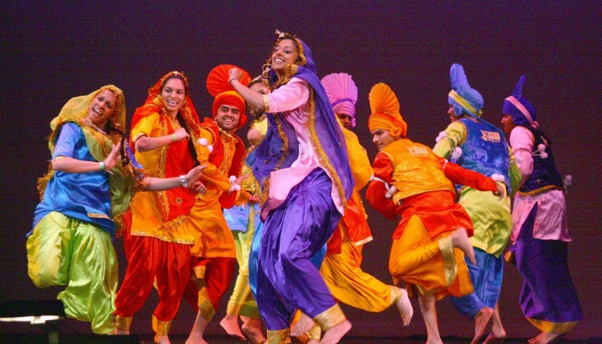

* 1. The Bihu dance is an indigenous folk dance from the Indian state of Assam related to the Bihu festival and an important part of Assamese culture.

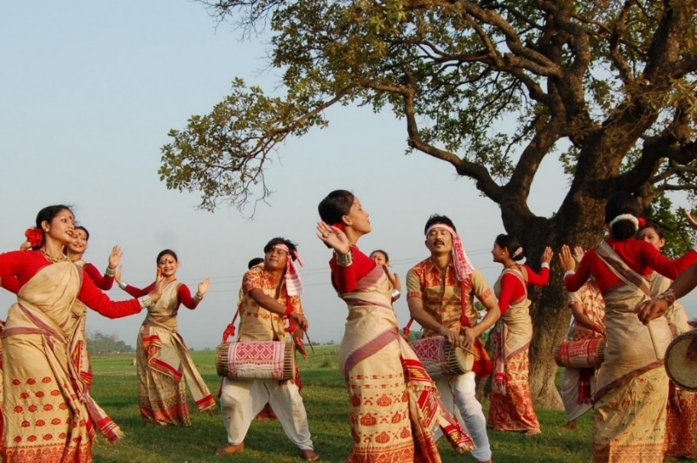

1. **Nature & Wildlife**
2. **Cold Desert, Himachal Pradesh**

One of the most fascinating biosphere reserves in India, Cold Desert is noted for the preservation of the snow leopard. It is stretched along the Western Himalayas, from Ladakh to Kinnaur, in Himachal Pradesh

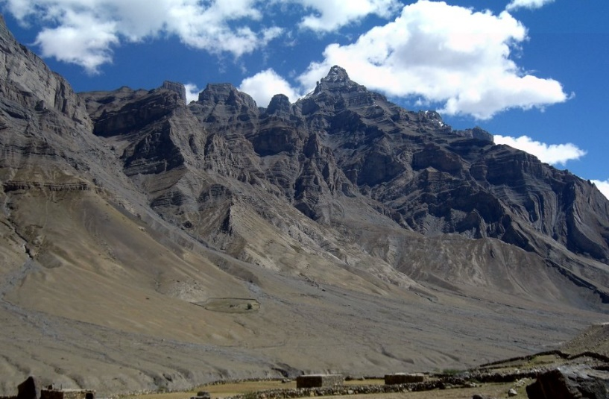

1. **Lake Pichola**, situated in Udaipur city in the Indian state of Rajasthan, is an artificial fresh water lake, created in the year 1362, named after the nearby Picholi village.

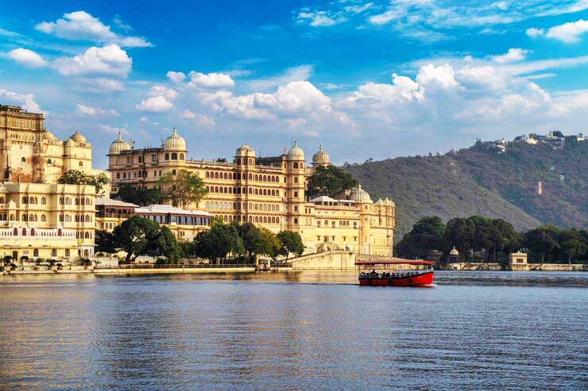

1. **Horsley Hills** in Andhra Pradesh is a slope station in Andhra Pradesh, which encounters a seriously charming and chilly climate consistently.

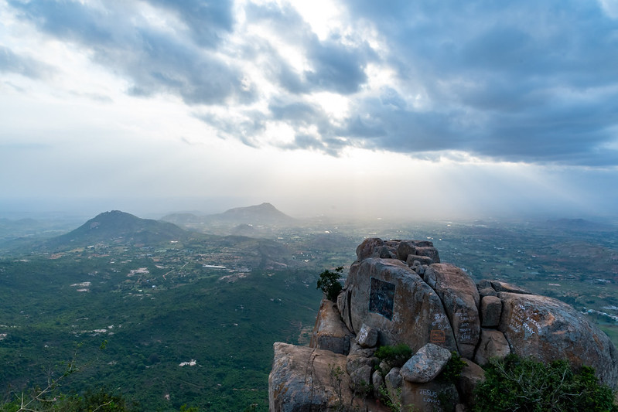

1. **Hemis National Park** is a high-elevation national park in Ladakh, India. Globally famous for its snow leopards, it is believed to have the highest density of them in any protected area in the world.

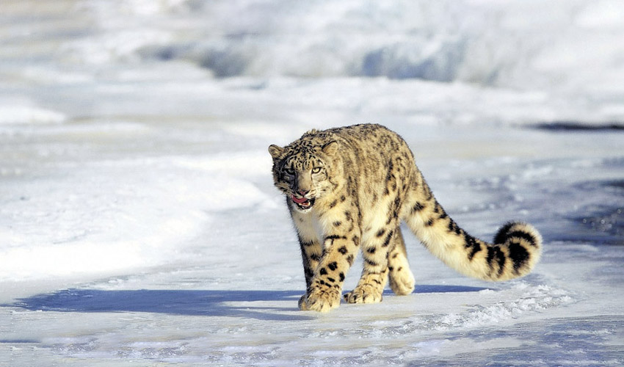

1. **Sanguthurai Beach** is one of the cleanest and calmest beaches. A beautiful expanse of white sand flanked by pristine and lukewarm water, the beach is an idyllic spot to relax and rejuvenate.

